**TEAM POTATO**

**Milestone 3**

In this milestone, we were asked to model RDT2.1, which specifies that there is a sequence number attached to each data transfer (excluding ACK and NAK). If the data is retransferred, we are guaranteed that the transfer will be a success (again excluding ACK and NAK). Following is the trace where there are no failures. Then we will show a trace with one failure, but ultimate success.

**State 0**

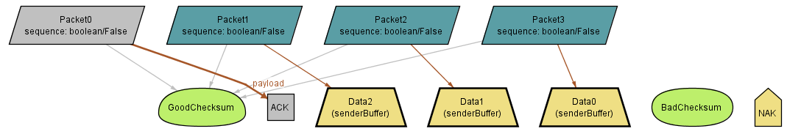

**State 1**

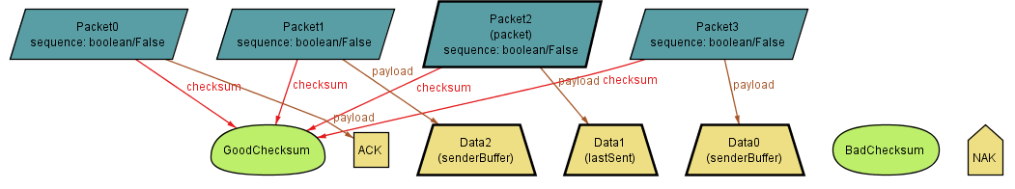

**State 2**

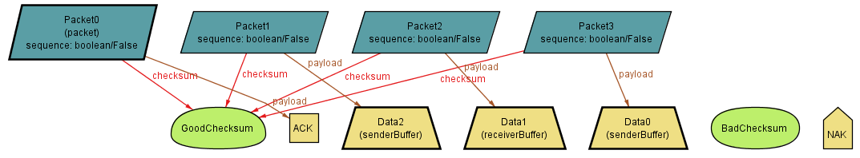

**State 3**

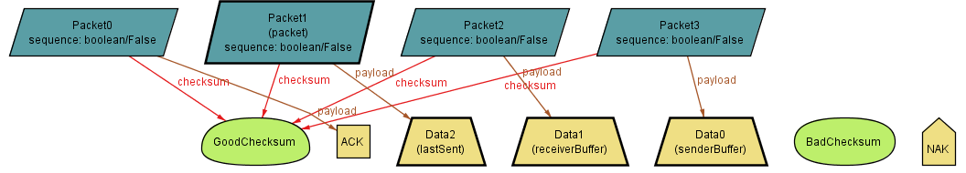

**State 4**

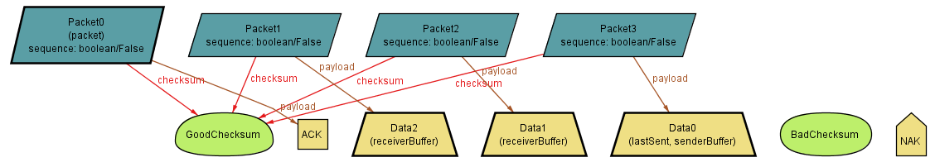

**State 5**

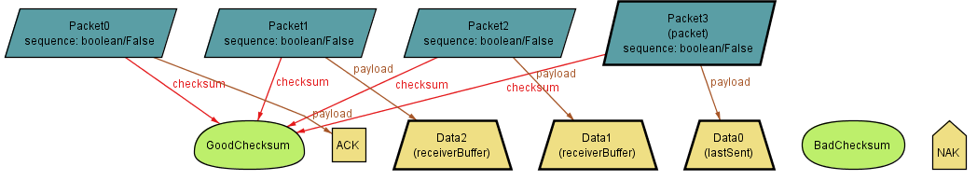

**State 6**

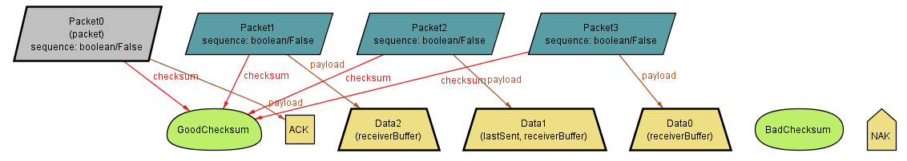

|  |  |  |  |
| --- | --- | --- | --- |
| **State** | **Send Buffer** | **Receiver Buffer** | **Packet in Channel** |
| 0 | 0, 1, 2 | - | - |
| 1 | 0, 2 | - | P2 -> Data1, GoodCs, Seq = false |
| 2 | 0, 2 | 1 | P0 -> ACK, GoodCs, Seq = false |
| 3 | 0 | 1 | P1 -> Data2, GoodCs, Seq = false |
| 4 | 0 | 1, 2 | P0 -> ACK, GoodCs, Seq = false |
| 5 | - | 1, 2 | P3 -> Data0, GoodCs, Seq = false |
| 6 | - | 0,1,2 | P0 -> ACK, GoodCs, Seq = false |

Now we move on to the trace where the data is successfully transferred but has one failure to transfer involved.

**State 0**

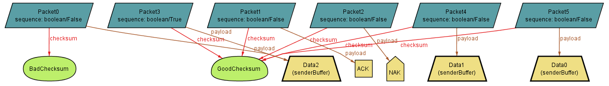

**State 1**

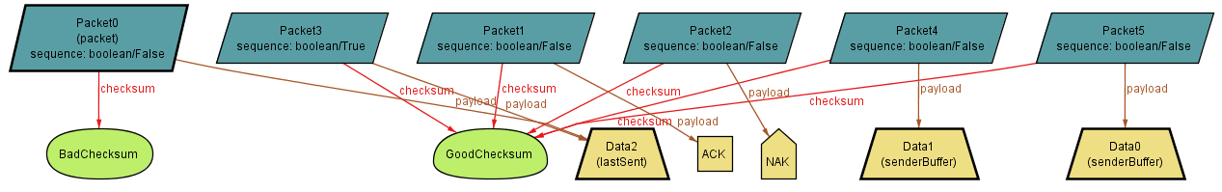

**State 2**

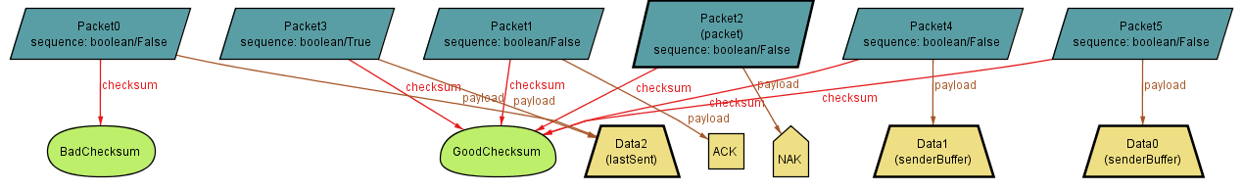

**State 3**

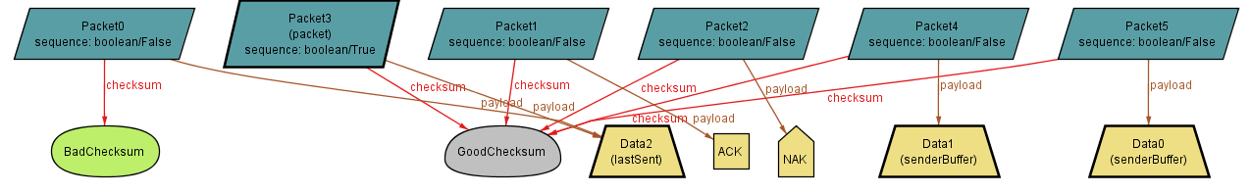

**State 4**

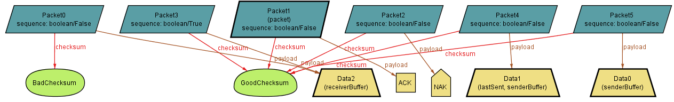

**State 5**

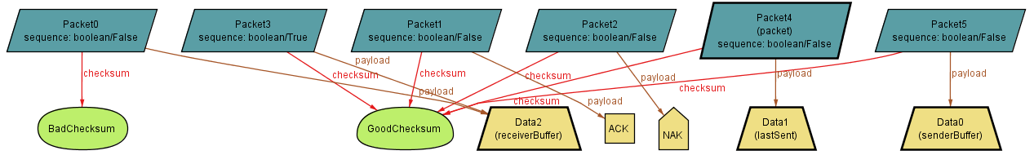

**State 6**

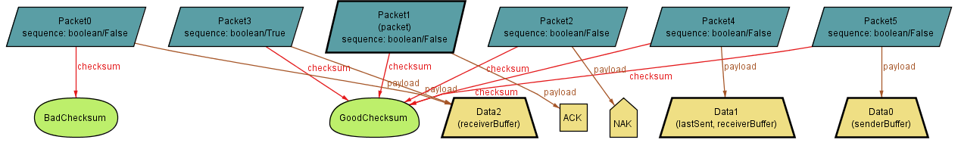

**State 7**

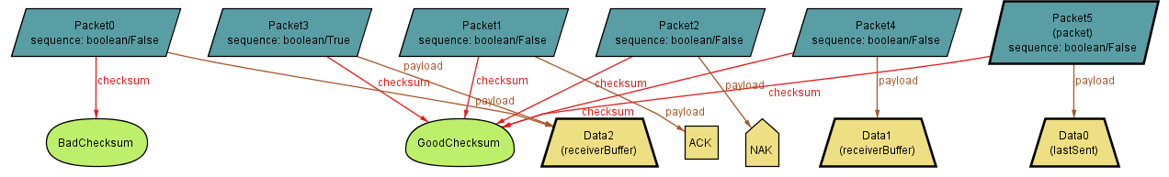

**State 8**

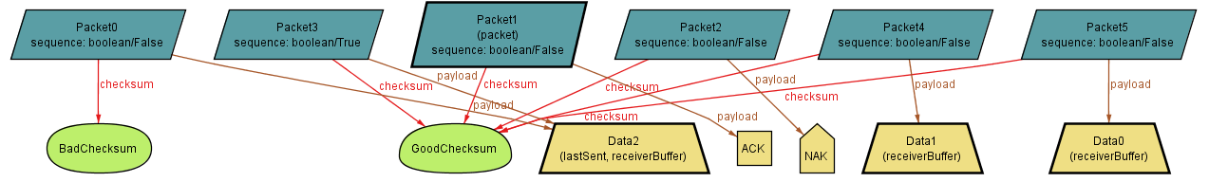

|  |  |  |  |
| --- | --- | --- | --- |
| **State** | **Send Buffer** | **Receiver Buffer** | **Packet in Channel** |
| 0 | 0, 1, 2 | - | - |
| 1 | 0, 1 | - | P0 -> Data2, BadCs, Seq = false |
| 2 | 0, 1 | - | P2 -> NAK, GoodCs, Seq = false |
| 3 | 0, 1 | - | P3 -> Data2, GoodCs, Seq = true |
| 4 | 0, 1 | 2 | P1 -> ACK, GoodCs, Seq = false |
| 5 | 0 | 2 | P4 -> Data1, GoodCs, Seq = false |
| 6 | 0 | 2, 1 | P1 -> ACK, GoodCs, Seq = false |
| 7 | - | 2, 1 | P5 -> Data0, GoodCs, Seq = false |
| 8 | - | 2, 1, 0 | P1 -> ACK, GoodCs, Seq = false |

With this model, if given enough states, the data may not always be transferred, because it possible that we will receive corrupted ACK’s indefinitely.